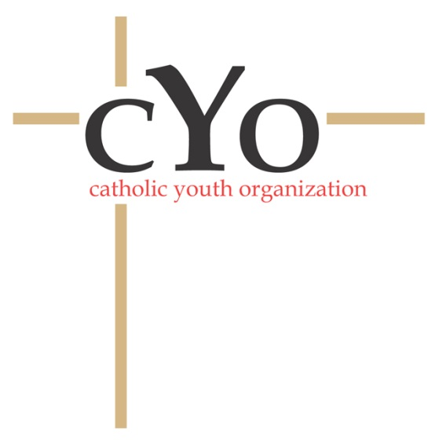[](http://www.chsl.com/)

**CONCUSSION AWARENESS**

**EDUCATIONAL MATERIAL ACKNOWLEDGEMENT**

By my name and signature below, I acknowledge in accordance with Public Acts 342 and 343 of 2012 that I have received and reviewed the Concussion Fact Sheet for Parents and Students provided by ______St. Joseph School___________________________

___________________________________

Student Name Printed

___________________________________

Student Name Signature

___________________________________

Date

___________________________________

Parent or Guardian Name Printed

___________________________________

Parent or Guardian Signature

___________________________________

Date

Return this signed form to the School/Parish. The School/Parish must keep this on file for the duration of enrollment/participation and until age 25.

Students and parents should review and keep the educational materials available for future reference.

